1. **Write a JavaScript program to find the factorial of a number.**

**Answer :-**

**Program :-**

<!DOCTYPE html>

<html>

<head>

<title>Factorial</title>

<script>

function getFactorial(){

var i,num,fact=1;

num=Number(document.getElementById("number").value);

for(i=1;i<=num;i++){

fact*=i;

}

document.getElementById("answer").value=fact;

}

</script>

</head>

<body>

<h2>Javascript Program to find Factorial of a Number</h2>

Enter the Number: <input id="number">

<br><br>

<button onclick="getFactorial()">Find Factorial</button>

<br><br>

Factorial: <input id="answer">

</body>

</html>

**Output :-**

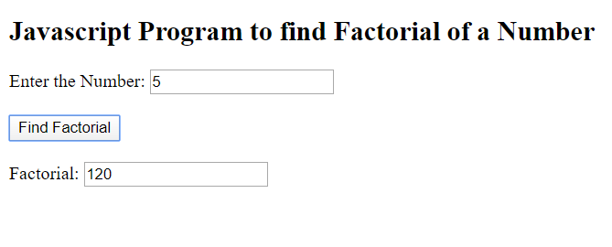

1. **Write a JavaScript code to solve a quadratic equation by reading the coefficients through dialog box. Also use confirm dialog box to check whether user wants to continue or not.**

**Answer :-**

**Program :-**

<!DOCTYPE html>

<html>

<head>

<title>Quadratic Equation</title>

<script>

function solveQuadratic(){

var d,a,b,c,ans1,ans2;

a=Number(document.getElementById("x2").value);

b=Number(document.getElementById("x1").value);

c=Number(document.getElementById("const").value);

d=(b*b)-(4*a*c);

if(d>0){

ans1=((-b)+Math.sqrt(d))/(2*a);

ans2=((-b)-Math.sqrt(d))/(2*a);

document.getElementById("answer1").value=ans1;

document.getElementById("answer2").value=ans2;

}

else if(d==0){

ans1=(-b)/(2*a);

ans2=ans1;

document.getElementById("answer1").value=ans1;

document.getElementById("answer2").value=ans2;

}

else{

document.getElementById("answer1").value="Imaginary Value";

document.getElementById("answer2").value="Imaginary Value";

}

}

function exit(){

document.write("Program Exited!")

}

</script>

</head>

<body>

<h2>Javascript Program to Solve a Quadratic Equation</h2>

Coefficient of x^2: <input id="x2">

<br><br>

Coefficient of x: <input id="x1">

<br><br>

Constant: <input id="const">

<br><br>

<button onclick="solveQuadratic()">Confirm</button>

<button onclick="exit()">Exit</button>

<hr>

x = <input id="answer1">

<br>OR<br>

x = <input id="answer2">

</body>

</html>

**Output :-**

1. **Input :-**

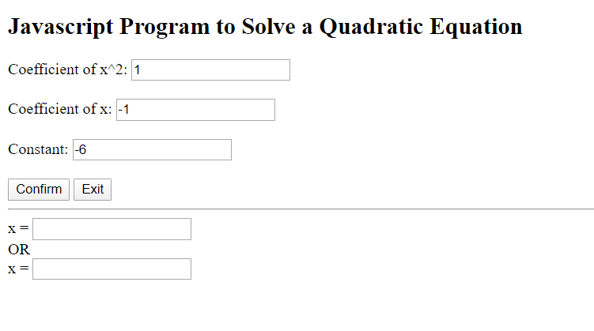

1. **Confirm :-**

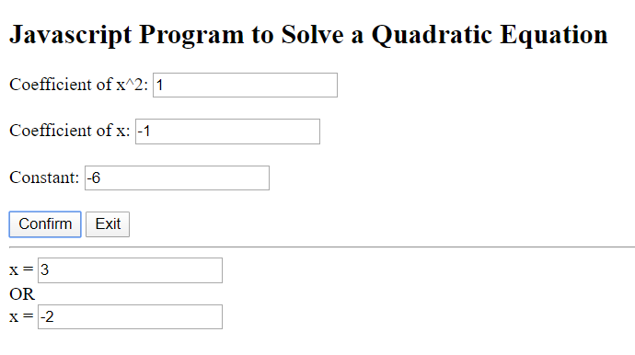

1. **Exit :-**



1. **Explain various String properties and methods present in JavaScript.**

**Answer :-**

The JavaScript String object is a global object that is used to store strings. A string is a sequence of letters, numbers, special characters and arithmetic values or combination of all.

**String Properties**

The following table lists the standard properties of the String object.

|  |  |
| --- | --- |
| **Property** | **Description** |
| length | Returns the length of a string. |
| prototype | Allows you to add new properties and methods to an String object. |

## String Methods

## The following table lists the standard methods of the String object.

|  |  |
| --- | --- |
| **Method** | **Description** |
| charAt() | Returns the character at the specified index. |
| charCodeAt() | Returns the Unicode of the character at the specified index. |
| concat() | Joins two or more strings, and returns a new string. |
| endsWith() | Checks whether a string ends with a specified substring. |
| fromCharCode() | Converts Unicode values to characters. |
| includes() | Checks whether a string contains the specified substring. |
| indexOf() | Returns the index of the first occurrence of the specified value in a string. |
| lastIndexOf() | Returns the index of the last occurrence of the specified value in a string. |
| localeCompare() | Compares two strings in the current locale. |
| match() | Matches a string against a regular expression, and returns an array of all matches. |
| repeat() | Returns a new string which contains the specified number of copies of the original string. |
| replace() | Replaces the occurrences of a string or pattern inside a string with another string, and return a new string without modifying the original string. |
| search() | Searches a string against a regular expression, and returns the index of the first match. |
| slice() | Extracts a portion of a string and returns it as a new string. |
| split() | Splits a string into an array of substrings. |
| startsWith() | Checks whether a string begins with a specified substring. |
| substr() | Extracts the part of a string between the start index and a number of characters after it. |
| substring() | Extracts the part of a string between the start and end indexes. |
| toLocaleLowerCase() | Converts a string to lowercase letters, according to host machine's current locale. |
| toLocaleUpperCase() | Converts a string to uppercase letters, according to host machine's current locale. |
| toLowerCase() | Converts a string to lowercase letters. |
| toString() | Returns a string representing the specified object. |
| toUpperCase() | Converts a string to uppercase letters. |
| trim() | Removes whitespace from both ends of a string. |
| valueOf() | Returns the primitive value of a String object. |

1. **Create a sample form program that collects the first name, last name, email, user id, password and confirms password from the user. All the inputs are mandatory and email address entered should be in correct format. Also, the values entered in the password and confirm password textboxes should be the same. After validating using JavaScript, In output display proper error messages in red color just next to the textbox where there is an error.**

**Answer :-**

**Program :-**

1. **Sample Form :-**

<!DOCTYPE html>

<html>

<head>

<title>Sample Form</title>

<script>

function validate_fname(){

var fn,text;

fn=sample.fname.value;

if(fn.length==0){

text="Invalid First Name!!";

text=text.fontcolor("red");

document.getElementById("firstname").innerHTML=text;

}

}

function validate_lname(){

var ln,text;

ln=sample.lname.value;

if(ln.length==0){

text="Invalid Last Name!!";

text=text.fontcolor("red");

document.getElementById("lastname").innerHTML=text;

}

}

function validate_email(){

var em,text;

em=document.getElementById("mail");

if(!em.checkValidity()){

text="Invalid Email!!";

text=text.fontcolor("red");

document.getElementById("email").innerHTML=text;

}

}

function validate_userid(){

var urid,text;

urid=sample.uid.value;

if(urid.length==0){

text="Invalid User ID!!";

text=text.fontcolor("red");

document.getElementById("userid").innerHTML=text;

}

}

function validate_password(){

var p,cp,text;

p=sample.pass.value;

cp=sample.confpass.value;

if(p!=cp){

text="Passwords do not Match!!";

text=text.fontcolor("red");

document.getElementById("confirmpassword").innerHTML=text;

}

}

</script>

</head>

<body>

<h2>Sample Form Program using Javascript</h2>

<p style="color: red;">All fields marked with * are mandatory.</p>

<form name="sample" action="action.html">

* First Name: <input type="text" name="fname" id="fname" onblur="validate_fname()"/> <span id="firstname"></span><br><br>

* Last Name: <input type="text" name="lname" id="lname" onblur="validate_lname()"/> <span id="lastname"></span><br><br>

* Email: <input type="email" name="mail" id="mail" onblur="validate_email()"/> <span id="email"></span><br><br>

* User ID: <input type="text" name="uid" id="uid" onblur="validate_userid()"/> <span id="userid"></span><br><br>

* Password: <input type="password" name="pass" id="pass"/><span id="password"> </span><br><br>

* Confirm Password: <input type="password" name="confpass" id="confpass" onblur="validate_password()"/> <span id="confirmpassword"></span><br><br>

<input type="submit" value="Submit"/>

</form>

</body>

</html>

1. **Action Page :-**

<!DOCTYPE html>

<html>

<head>

<title>Action Page</title>

</head>

<body>

<h2>Thank You Very Much</h2>

<p>You have submitted the following details:</p>

<ul>

<li>First Name</li>

<li>Last Name</li>

<li>Email</li>

<li>User ID</li>

<li>Password</li>

</ul>

</body>

</html>

**Output :-**

1. **Form Input :-**

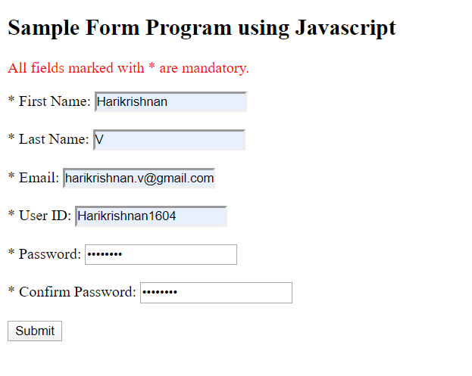

1. **Valid Input :-**

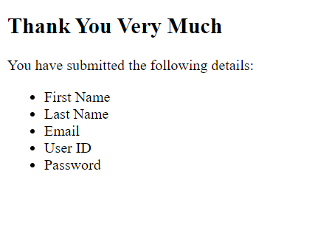

1. **Invalid Input :-**

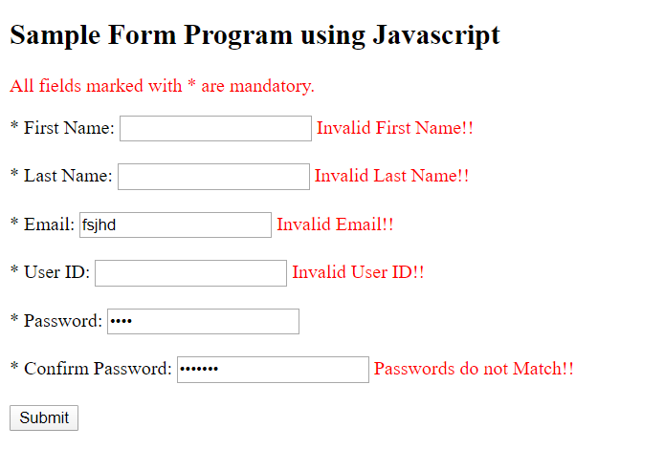

1. **What is === operator in Java Script?**

**Answer :-**

**Identity / strict equality (===)**

The identity operator returns true if the operands are strictly equal with no type conversion.

**Syntax**

x === y

**Examples**

3 === 3 // true

3 === '3' // false

var object1 = {'key': 'value'}, object2 = {'key': 'value'};

object1 === object2 //false

1. **Syntactic differences between HTML and XHTML.**

**Answer :-**

|  |  |
| --- | --- |
| **HTML** | **XHTML** |
| HTML is Hypertext Markup Language. | XHTML is Extensible Hypertext Markup Language. |
| An application of SGML. | An application of XML. |
| Can have empty/open tags.  e.g. <br>, <p>. | All the unclosed tags must be closed.  e.g. <br/>, <p></p>. |
| No hard rule on structures of the elements.  e.g. <p><b>  The difference</p></b>. | Structure of the elements should be followed.  e.g. <p><b>  The difference</b></p>. |
| Attributes have quotes as optional.  e.g. <font color=#ff0000>. | Attributes have quotes mandatory.  e.g. <font color=”#ff0000?>. |
| Attributes values not significant.  e.g. <input type=”checkbox” checked>. | Attributes values are important.  e.g. <input type=”checkbox” checked = “checked”>. |
| Case insensitive: The tags and attributes can be of uppercase or lowercase as per the preference. | Case sensitive: The tags and attributes must be of lowercase. |
| All the content can be put under body element. | All the content has to be put in blocks (p, under body element. |
| HTML is not mandatory for one root element. | XHTML documents must have one root element. |